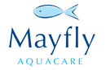

Fish availability & prices Autumn 2015

**Size   Per 100 Fish       Per 500 Fish       Per 1000 Fish**

**Bream**

1-4lb               £7/lb.

**Carp**

1-5lb                £5.50/lb.

5-9lb                £6.50/lb.

10 –14lb         £13/lb.

14-19lb           £16.50/lb.

20-24lb           £34/lb.

25lb + limited availability please call for prices.

**Tench**

6-8 “ £380

8-10” £580

1lb+ £15.20/lb

All prices plus VAT @ 20% and delivery.

For further information please contact us via [miles@mayflyaquacare.co.uk](mailto:miles@mayflyaquacare.co.uk) or Landline : 01825 840 868

mobile : 07974 76 66 74

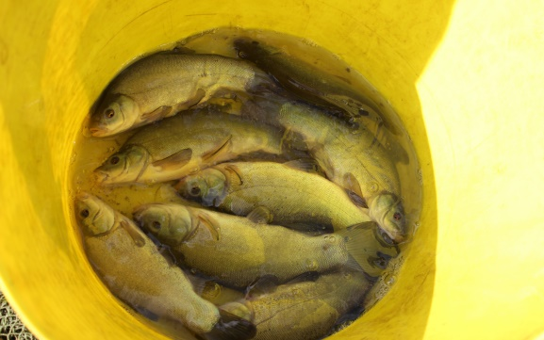

All our fish are farm reared on our Cefas registered site in East Sussex.

Our farmed carp originate from the ‘Longreed’ strain, which has this year produced several fish between 40lb & 46lb 1oz. These fish have shown growth rates of up to 1lb a month, yet remain well proportioned.

